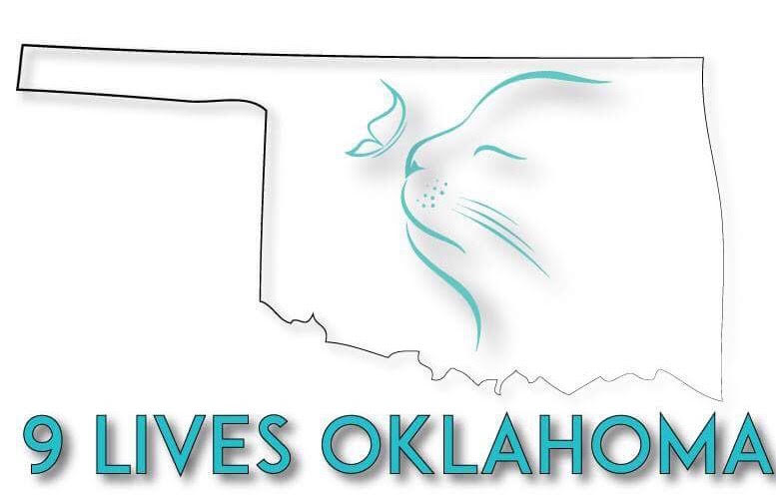
9 Lives Rescue Oklahoma Adoption Application
Hinton, Oklahoma
9livesrescueok@gmail.com
405-668-3228 405-747-0816

Date_____________
Adopter Name______________________Phone#________________Alt#___________
Address____________________City_______________State______Zip____________
Email______________________________Drivers Licence#______________________
Who will be primary caregiver of the cat?_____________________________________
Reason for wanting cat? Companion____ Mouser____ For children____ Gift_________
Veterinarian Name_____________________City__________Phone#______________

Do you own your home? Yes____ No_____ Rent______
If you rent, do you have the landlord’s permission to keep a cat? _____Yes______No
Landlord’s Name_______________________Phone#_________________Alt#_____________

Who lives in the home with you? Spouse ______ Children ______ Roomate_______ Other______ #Of children ________ Ages____,_____,____,______
Does anyone who lives in the home have an allergy to cats ____Yes ______No
If yes, how do you plan to cope with allergies?______________________________________
Where will your cat live? Indoors Only _________ Outdoors Only _______ Both__________
Where is your home located? In-Town_____ Country_________
If cat stops using the litter box, you will?____________________________________________
Where will cat spend the night?___________________________________________________

Please list all pets you have owned in the last 5 years:
Breed | Age | Sex | Spayed/  Neutered? | #Of Years  Owned? | Still Live  With You? | If Not, Why?

Agreement:
Adopter History- Adopter agrees that he/she has never been convicted of animal cruelty and that there are no court orders stating that the adopter may not adopt or care for an animal.
No Representations: The Adopter understands that no guarantees have been made by 9 Lives Rescue Oklahoma in regards to the health, temperament or training of the above mentioned cat.
First 7-14 Days- The Adopter agrees to keep cat(s) in an isolated place, where cat cannot escape, for a minimum of 7 days to allow the cat(s) to acclimate to its new environment. During this time, Adopter agrees to provide fresh water, food and a litter box.
Care- Adopter understands that fresh water and food MUST be provided at ALL times to the barn cat(s) for the extent of the cat’s lives. Adopter agrees that the cats will not be forced to “survive” on rodent and snake populations.
Check-up- Adopter agrees to provide access to property for 9 Lives Rescue Oklahoma at any time in order to check on health, care and wellbeing of cats.
Licences/Identification: The Adopter agrees to obtain proper municipal licences if required by local law. The Adopter also agrees to comply with local and state statutes and ordinances.
Address Change: The Adopter agrees that in the event of a change of address, he/she will contact 9 Lives Rescue Oklahoma with the new information so that all records can be updated.
Impoundment: If the cat shall, for any reason, be picked up by animal control or local law enforcement, the Adopter will immediately contact 9 Lives Rescue Oklahoma directly and inform them of the location of the cat. The Adopter will also inform authorities which are holding the cat that the animal is under ultimate ownership by 9 Lives Rescue Oklahoma and provide them with 9 Lives contact information. Under no circumstances will the adopter agree to or allow the euthanasia of said cat before contacting 9 Lives Rescue Oklahoma.
Release: The Adopter, and for his/her spouse, family members, heirs, executors, personal representatives and assigns to never bring suit against 9 Lives Rescue Oklahoma. The Adopter releases 9 Lives Rescue Oklahoma and its founders, board members, employees, officers, agents, representatives, contractors, volunteers, successors and assigns from all liability arising from the adoption, actions or behavior of the cat.
The Adopter understands that that this agreement discharges 9 Lives Rescue Oklahoma and its founders, board members, employees, officers, agents, representatives, contractors, volunteers, successors and assigns from any liability to the Adopter, his/her spouse, family members, heirs, executors, personal representatives and assigns, with respect to bodily injury, personal injury, illness, scarring, amputation, death, property damage,or other loss that may result from the adoption, behavior or actions of the cat.
Indemnity: The Adopter, and for his/her spouse, family members, heirs, executors, personal representatives and assigns to indemnify and hold 9 Lives Rescue Oklahoma harmless for all bodily injury, personal injury, illness, scarring, amputation, death, property damage or other loss, including attorney’s fees and costs of litigation, that result to anyone else or any other entity because of the Adopters negligence or liability. This includes the lone acts or omissions by the Adopter as well as the combined acts of the Adopter with others.
Return Policy: 9 Lives Rescue Oklahoma has a lifetime commitment to all of its animals. The Adopter agrees that if at any time he/she is unwilling or unable to care for the cat at any point in its lifetime, he/she will contact 9 Lives Rescue Oklahoma and return the cat to the location and time specified by 9 Lives Rescue Oklahoma. The Adopter understands that he/she is responsible for the cat’s wellbeing and care until said cat is delivered to Nine Lives Rescue Oklahoma. Under no circumstances shall the Adopter transfer permanent ownership, custody or possession to any one entity, including family, friends or any other adoption agency or animal shelter without the approval and written consent of 9 Lives Rescue Oklahoma.

9 Lives Rescue Oklahoma is an Oklahoma 501(c)(3) corporation. 9 Lives Rescue Oklahoma and the Adopter enter into this agreement to provide the above mention cat with a suitable forever home. The Adopter states that the information provided in the contract is true and correct.

The Adopter agrees that is he/she is 18 years of age or older on the date of signing. The Adopter agrees that he/she is legally competent to enter into this agreement, and this Agreement is binding upon the heirs, assigns, successors, personal representatives and executors of both parties.

Please Read and Sign: Many factors will determine which applicate will be matched with a particular cat. If you are not able to adopt a pet today, it does not mean you are considered a bad pet owner or that your home is not acceptable. Our goal is to place cats in a home that meets their individual needs.
[ ] I have completed this application truthfully and understand the adoption process.

______________________________________________ Date: __________________
Signature of Adopter

_______________________________________________
Signature of 9 Lives Rescue of Oklahoma Representative Date: __________________

